Multiple choice section

|  |  |  |  |  |  |  |  |  |
| --- | --- | --- | --- | --- | --- | --- | --- | --- |
| Question | 1 | 2 | 3 | 4 | 5 | 6 | 7 | 8 |
| Answer | C | A | C | D | C | B | B | C |

Question 1 [7.1]

C

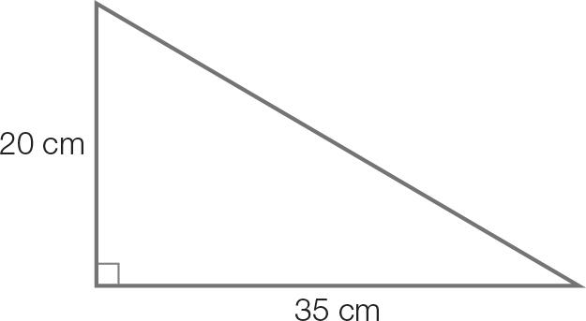

x2 = 202 + 352

x2 = 1625

x =

x = 40.311…

x = 40 cm (correct to the nearest cm)

Question 2

A [7.1]

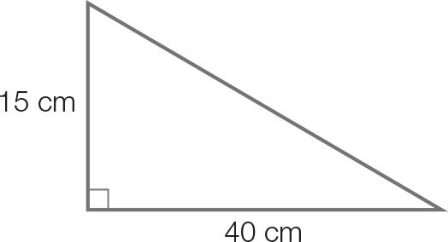

x2 = 2 + 152

x2 = 1850

x =

x = 43.01…

x = 43 cm (correct to the nearest cm)

Question 3 [7.1]

C

CA =  ≈ 40 cm

CH = 15 cm

tan(θ) = 

θ = tan -1

θ = 20 (correct to the nearest degree)

Question 4 [7.2]

D

sin(277) = −sin(360 − 277)

= −sin(83)

Question 5 [7.2]

C

Amplitude = (3 – (−3)) = 3

Period = 360 − 0 = 360

Question 6 [7.3]

B

3 − 6 cos(x) = 0

cos(x) =

In the 1st quadrant x = 60

cos(x) is also positive in the 4th quadrant

x = 360 − 60 = 300

Question 7 [7.4]

B



Question 8 [7.6]

C

The third angle of the triangle is 180 – 80 – 70 = 30.

A = × 6 × 10 × sin(30)

=× 6 × 10 × 0.5

= 15 cm2

Multiple-choice total marks: 8

Short answer section

Question 9 4 marks [7.1]

(a) Find the diagonal distance across the base.  
x2 = 222 + 302  
x2 = 1384  
x =    
x = 37.2 cm

(b) Find the diagonal distance across the rectangular face of the wedge.  
x2 = 282 +302  
x2 = 1684  
x =    
x = 41.036…   
x = 41.0 cm

(c) x2 = 282 – 222  
x2 = 300  
x =    
x = 17.320…   
x = 17.3 cm

(d) Angle ROP will be the same value as angle QNM.  
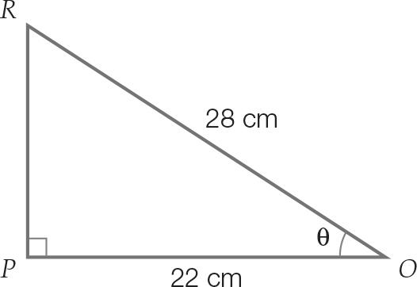  
cos(θ) =    
θ = cos-1  
θ = 38.213…  
θ = 38 (rounded to the nearest degree)

Question 10 2 marks [7.1]

Length of diagonal on base is(or use 3, 4, 5 Pythagorean triple)

Angle with base:  
θ = tan-1

= 38.66

Question 11 2 marks [7.1]

Let θ be the angle the straw makes with the base.

sin(θ) = 

θ = sin-1

= 63.47

Question 12 3 marks [7.2]

(a) sin(254) = sin(180 + 74)  
= -sin(74) [sin(θ) is negative in the 3rd quadrant]

(b) cos(313) = cos(360 − 47)   
= cos(47) [cos(θ) is positive in the 4th quadrant]

(c) tan(128) = tan(180 − 52)  
= -tan(52) [tan(θ) is negative in the 2nd quadrant]

Question 13 2 marks [7.2]

sin(28) in the 1st quadrant means φ is in the 3rd or 4th quadrant.

In the 3rd quadrant:

φ = 180 + 28 = 208

In the 4th quadrant:

φ = 360 − 28 = 332

Question 14 2 marks [7.2]

(a) Period = 180

(b) Amplitude = 1

Question 15 2 marks [7.3]

3 + 5 sin(x) = 0

sin(x) = 

sin(x) is negative in the 3rd and 4th quadrants

Question 16 4 marks [7.3]

8 cos(φ) + 5 = 0

cos(φ) =

cos(φ) is negative in 2nd and 3rd quadrants.

In the 1st quadrant, φ = cos-1 = 51.32

In 2nd quadrant, φ = (180 – 51.32)

= 128.68

Add and subtract multiples of 360

φ = (128.68 ± 360n), n = 0, 1, 2,…

In 3rd quadrant, φ = (180 + -51.32)

= 231.32

Add and subtract multiples of 360

φ = (231.32 ± 360n), n = 0, 1, 2,…

Question 17 2 marks [7.4]

x2 = 32 + 32 – 2 × 3 × 3 cos θ

= 9 + 9 – 18 cos θ

x =

Question 18 4 marks [7.4]

(a)

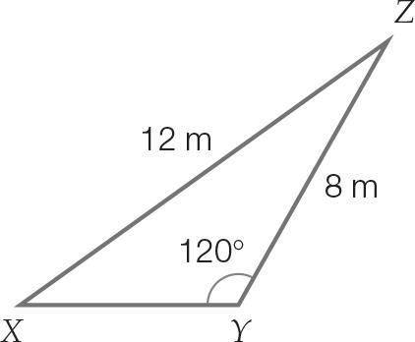

(b)   


(c) Remaining angle  
= 180 − (120 + 35)  
= 25

(d) To find XY you can use the sine rule.  
   
z = 5.79…  
z = 6 m (correct to the nearest metre)

Question 19 4 marks [7.4]

a = 3x, b = 4x, c = 2x

c2 = a2 + b2 − 2ab cos(C)

(2x)2 = (3x)2 + (4x)2 – 2(3x)(4x)cos(C)

4x2 = 9x2 +16x2 − 24x2 cos(C)

−21x2 = −24x2 cos(C)

cos-1= C

C = 28.96

Question 20 4 marks [7.5]

(a)

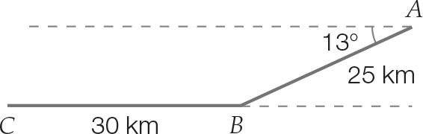

(b) The interior angle of the triangle is 180 – 13 = 167.

Let x be the direct distance for the flight.

Use the cosine formula:  
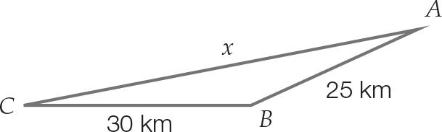  
x2 = 252 + 302 – 2 × 25 × 30 × cos(167)  
 = 2986.555  
 x = 54.649 km  
Distance saved = 25 + 30 – 54.649   
 = 0.351 km   
 = 351 m

Question 21 3 marks [7.6]

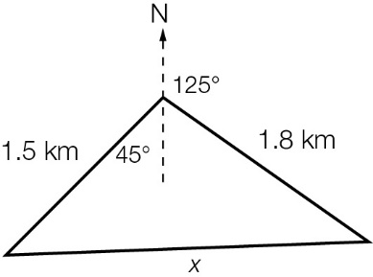

Angle at intersection of Tan St and Sine Avenue  
= (45 + 55)

= 100

Area =  × 1.5 × 1.8 × sin(100)

= 1.33 km2

Question 22 4 marks [7.6]

A =× a × b × sin(θ)

=

sin(θ) =

θ = 30

Short answer total marks: 42

Extended response section

Question 23 12 marks [7.1, 7.4, 7.5, 7.6]

(a) x2 = 82 + 152  
x = 17 m  
y = 15 tan(30  
 = 8.66  
d2 = 172 + y2  
 = 364  
d =   
d = 19.08 m

(b) θ = cos-1**  
= 27

(c) cos(30) = **  
f =   
= 17.32 m

(d) sin(φ) =   
 φ = sin-1  
 = 24.79

(e) Area =  × 17.32 ×  × sin(24.79)  
= 34.64 m2

(f) g2 = 17.322 + 9.542 – 2 × 17.32 × 9.54 × cos(24.79)  
= 90.98  
g = 9.54 m

Question 24 8 marks [7.2. 7.3]

(a) Period = 12 hours  
Amplitude =  
= 1

(b) High tide when x = 3  
Time = 7 am + 3 hours  
= 10 am Sunday

(c) 0.8 = sin(30x) + 0.5  
0.3 = sin(30x)  
30x = sin-1(0.3)  
 = 17.46, 162.54, 377.46, 522.54  
x = 0.58, 5.42, 12.58, 17.42 hours

(d) 2(5.42 – 0.58) = 2 × 4.84  
= 9.68 hours

Extended answer total marks: 20

TOTAL test marks: 70